Cairo University Faculty of Computers and Information



**CS352 – Software Engineering II**

**Phase 2 Template**

**2017**

**Project Team**

|  |  |  |  |
| --- | --- | --- | --- |
| **ID** | **Name** | **Email** | **Mobile** |
| 20140169 | Abdelaziz Mahmoud Abdelaziz | zizomody2511@gmail.com | 01063930937 |
| 20140219 | Mohamed Amged Hamed | popop9933@yahoo.com | 01006093286 |
| 20140203 | Fatma Elsayed | Elsayedfatoma@yahoo.com | 01205867520 |
| 20140170 | Abdallah Abdelazim Abdallah | Abdallah.abdelazim@hotmail.com | 01110095611 |

**-Ragia Mohamed**

Title page has no header or footer.

Docs must be supplied as pdf –files re-named as requested

Contents

Instructions [To be removed] 3

Your Restful API 3

Class diagram design 4

Daily scrum Meetings 5

Trello workspace screenshot 5

Github repository link 6

# Your Restful API

Use MVC

# Class diagram design

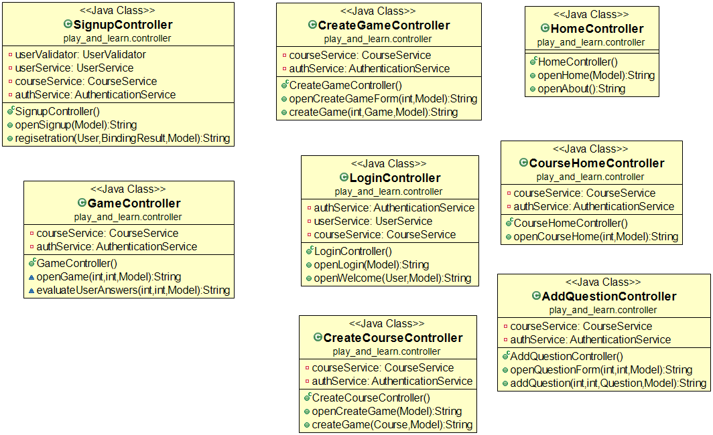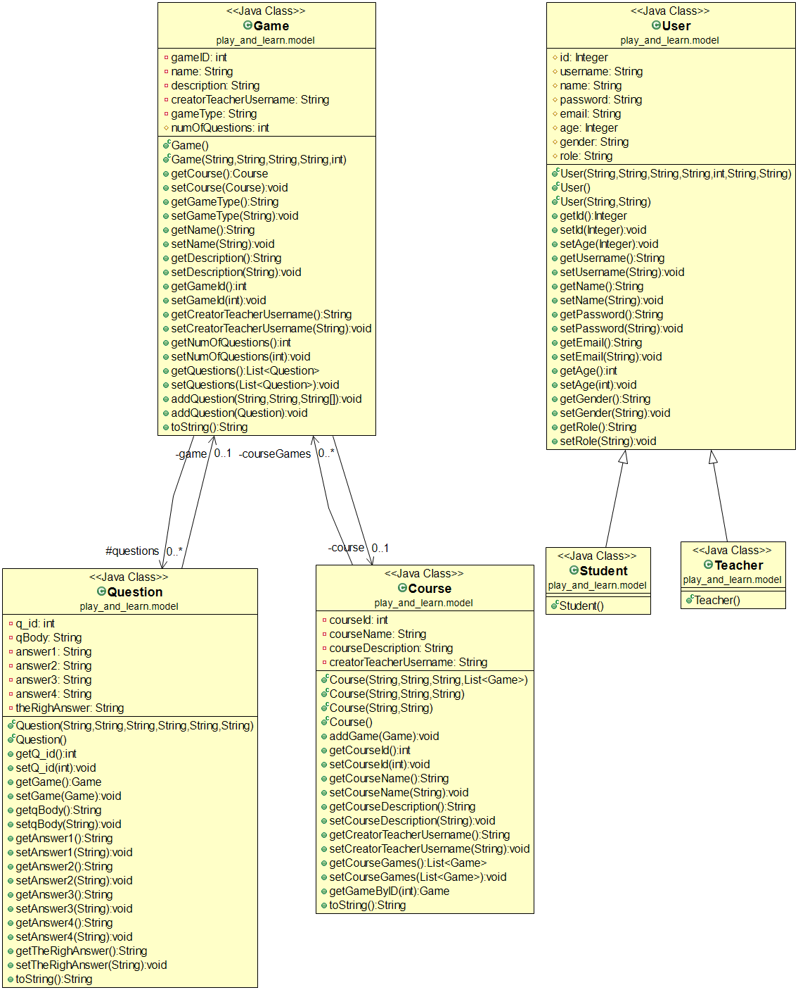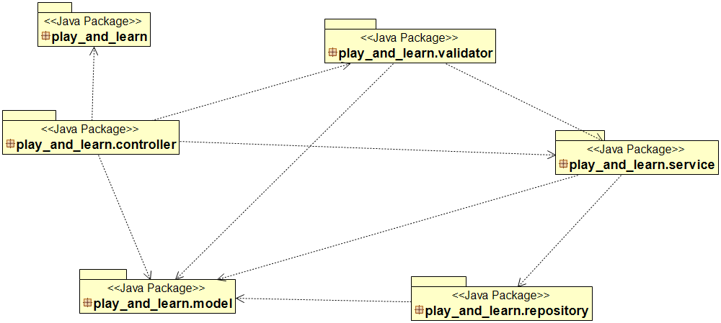

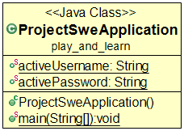

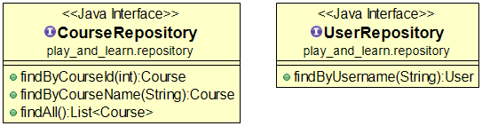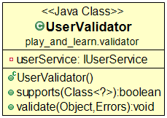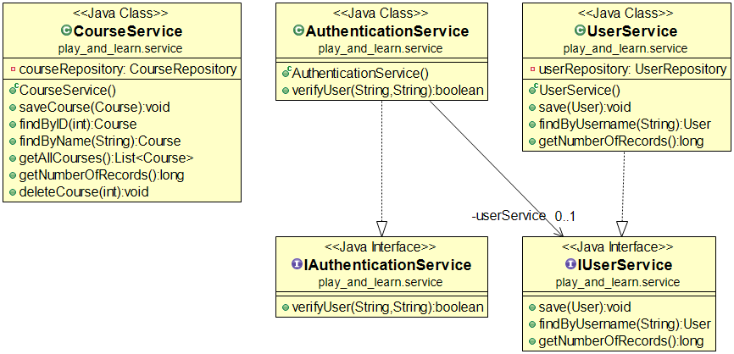

**Create course**

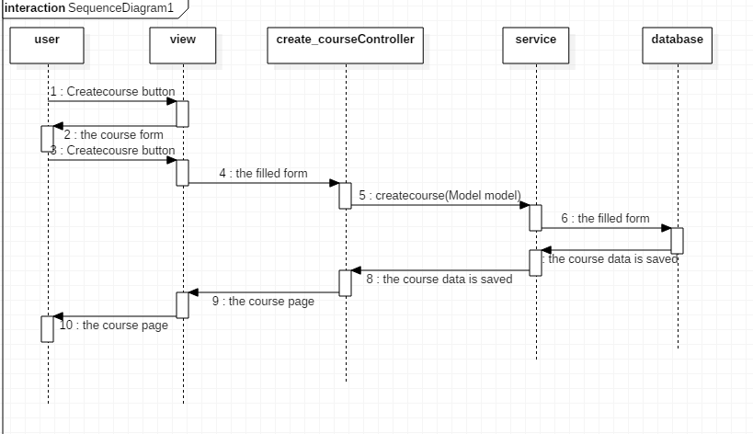

**Play gamecreate game**

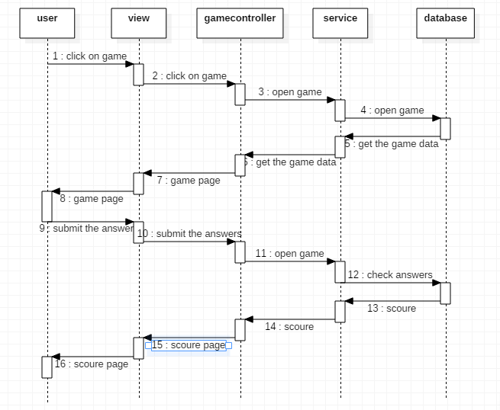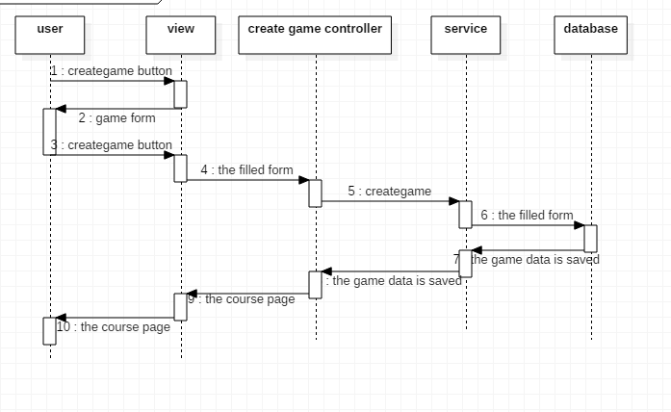

**Show courseslogin**

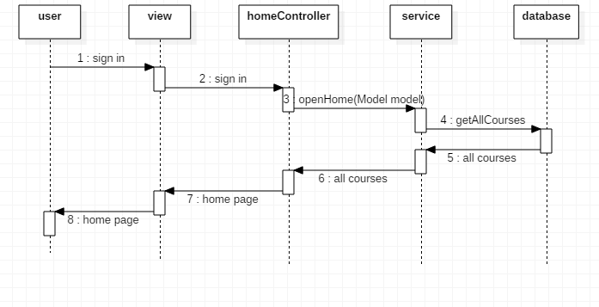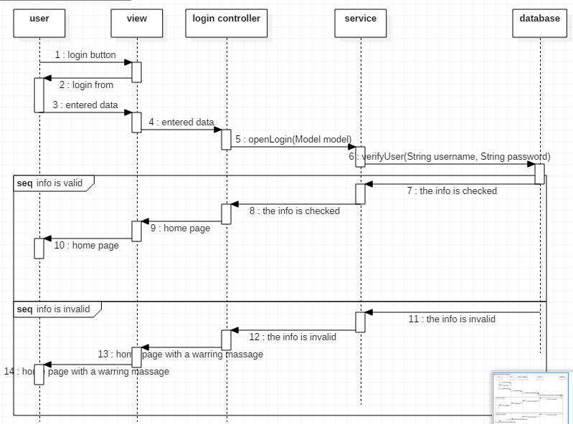

**Sign up**

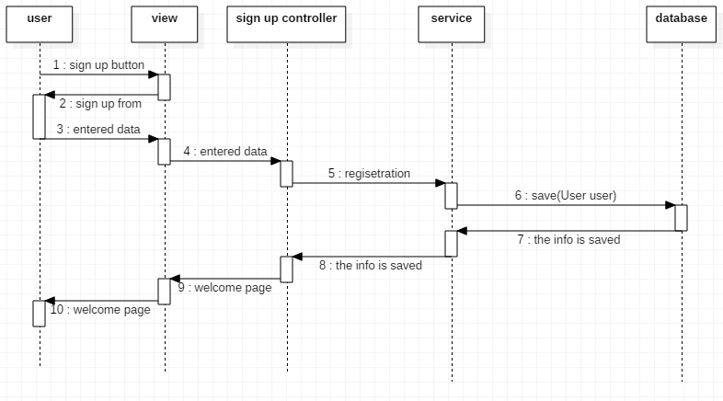

# Trello workspace screenshot

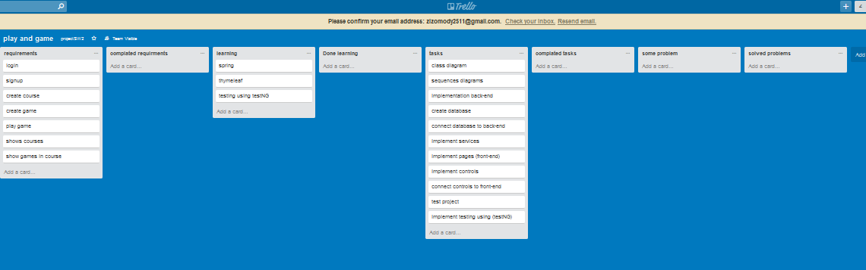

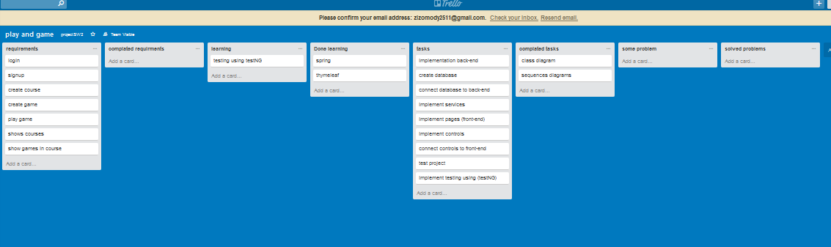

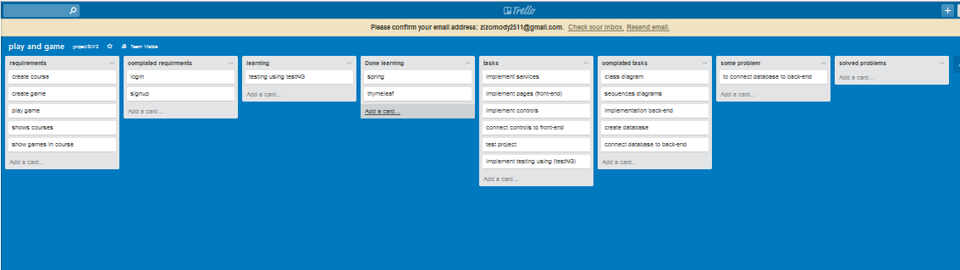

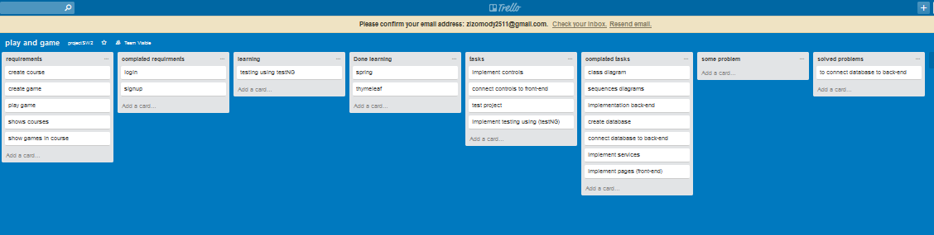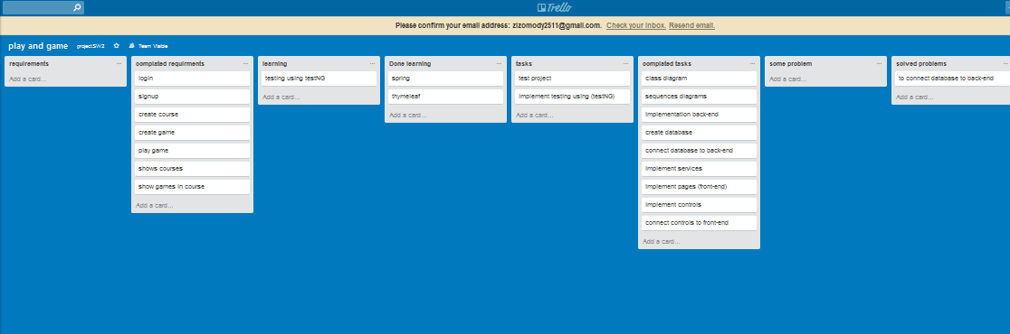



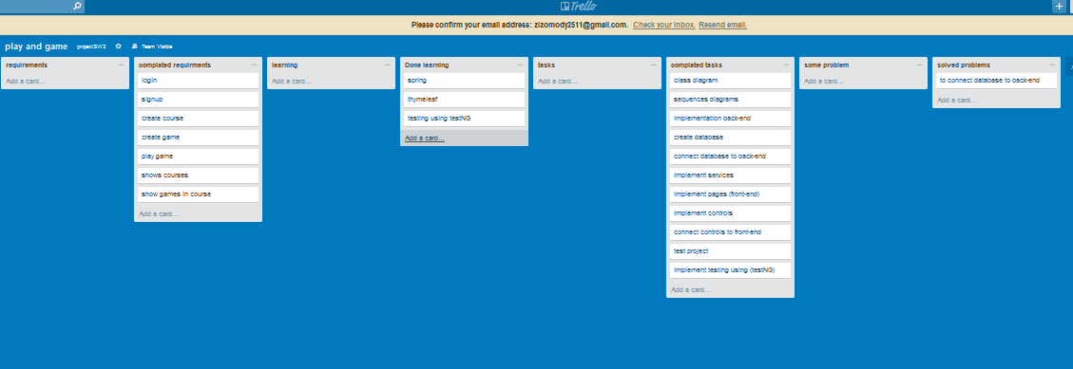

# Github repository link

* [**https://github.com/Abdallah-Abdelazim/Game-based-Educational-Platform**](https://github.com/Abdallah-Abdelazim/Game-based-Educational-Platform)
* ***Your implementation should follow coding style (java style) you should also provide documentation for each class in your project***